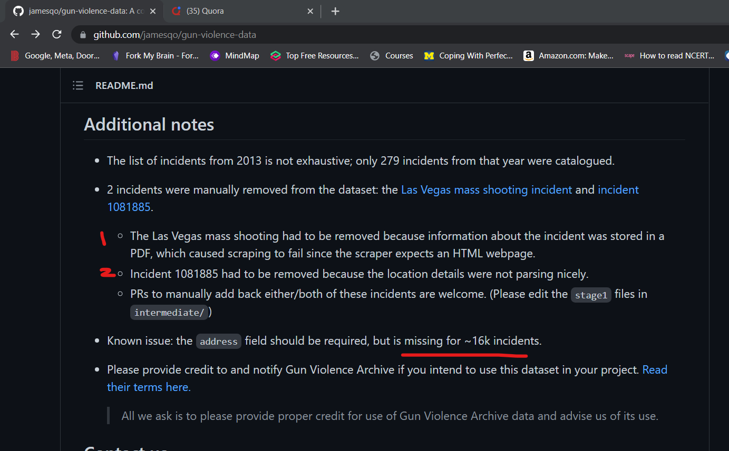

* Sort out static data set.
* Remove all rows with no incident ID.
* Find rows with faulty addresses, use incident id to scrape data and append to appropiately,
* Make data quality of columns is appropiate, many rows have abnormal entries, try to scrap else drop.